1. eConsent
When you start a file as a Pre-Application it will be a TBD.
Complete all blue fields except the estimated value (enter appraised value only) and use TBD for street address, enter city and state and zip (the city state and zip are need to run DU/LP).
Go to the 2015 Itemization and enter all loan type information, fees from closing/ title agent, request for transcript of tax information and home counseling providers.
.
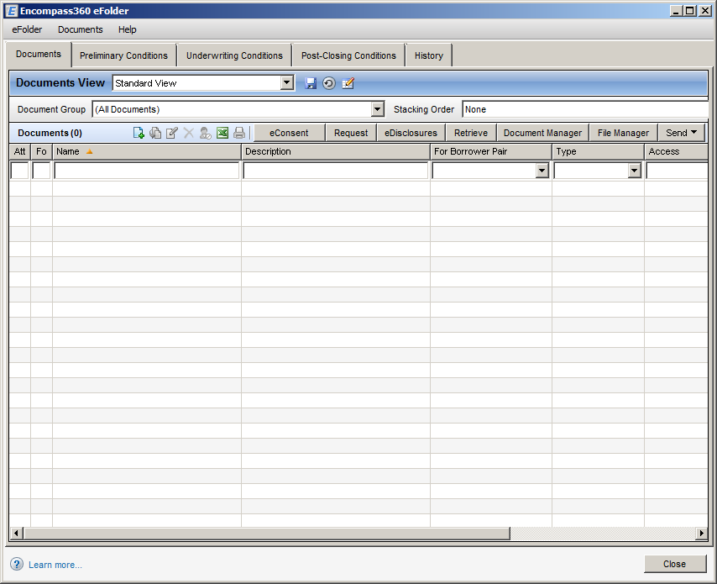
Select all borrowers to get the eConsent and select “notify me when borrower does not access by (pick date).
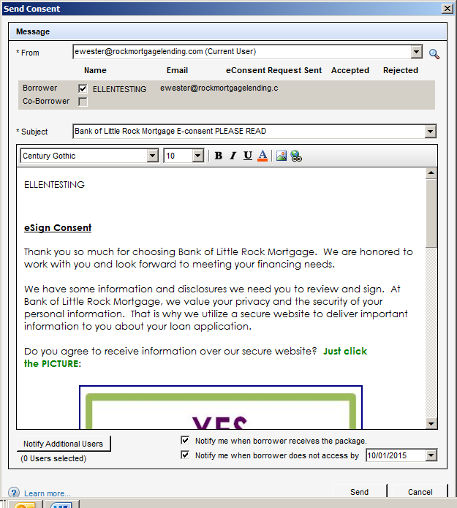
Click Send
Borrower will get below email.
From: Loan Officer [mailto:eFolder@elliemae.com]
Sent: Tuesday, September 29, 2015 2:15 PM
To: Customer Name
Subject: Bank of Little Rock Mortgage E-consent PLEASE READ

Customer Name,
eSign Consent
Thank you so much for choosing Bank of Little Rock Mortgage. We are honored to work with you and look forward to meeting your financing needs.
We have some information and disclosures we need you to review and sign. At Bank of Little Rock Mortgage, we value your privacy and the security of your personal information. That is why we utilize a secure website to deliver important information to you about your loan application.
Do you agree to receive information over our secure website? Just click the PICTURE:

Not working? Click Here
You will soon be receiving an additional email that will direct you to this information and disclosures. Please follow the directions therein at your earliest convenience. Please let me know if I can assist you with questions as we move forward. I will be in touch soon!
Please also remember to refer your friends and family to me. I would love an opportunity to help with their financing needs as well.
New to eSigning? Click here to watch a video that walks you through the eSigning process and explains how to use this website to view, sign and return the requested loan documents.
Thank you from your mortgage loan team:

The borrower will open the email and click “yes”. The will be directed to the Ellie Mae Loan Center. There they will need to set up their own password. Remind them this password will be used repeatedly.
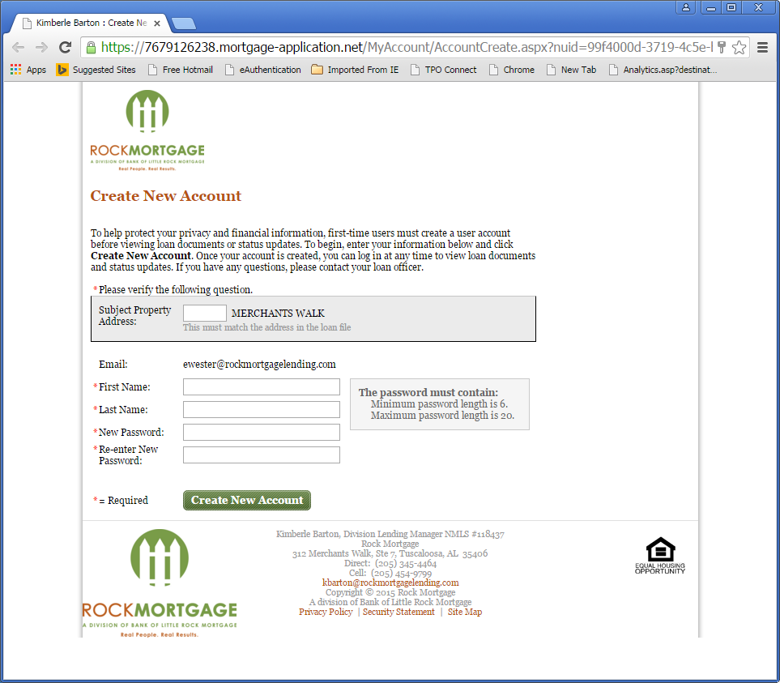
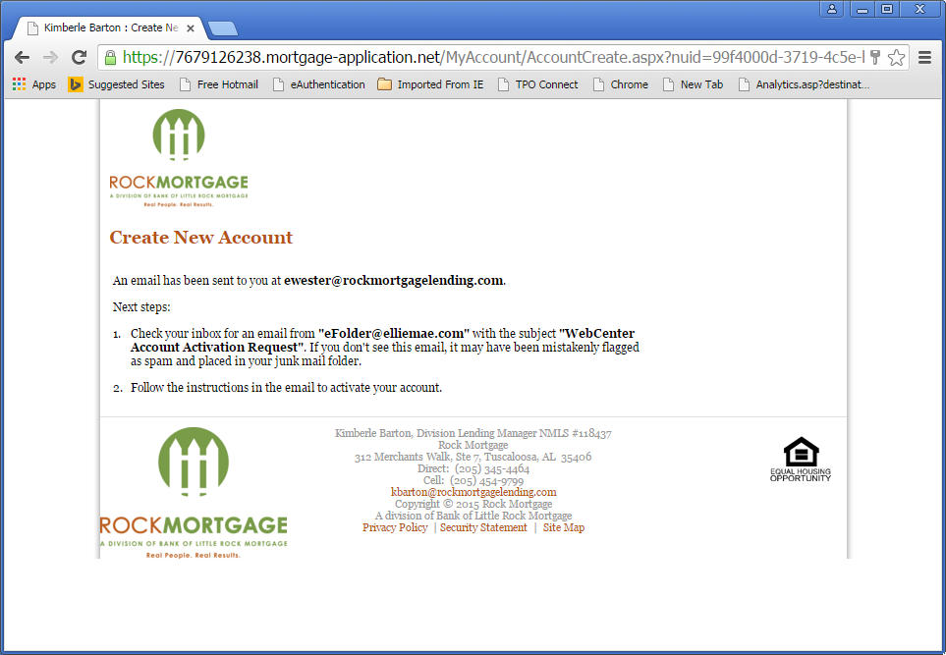
From: Rock Mortgage [mailto:eFolder@elliemae.com]
Sent: Wednesday, October 21, 2015 7:11 AM
To:
Subject: WebCenter Account Activation Request

Activate New Account

Customer Name is attempting to activate the customer email address account.
Click here to activate this account. The account password is required to complete the activation process.
If you experience problems opening the link, copy and paste the URL below into your Web browser.
URL:
https://7679126238.mortgage-application.net/myaccount/accountsignup.aspx?aid=2E9E9A61-B76B-4B80-A580-60B66A7D1D96

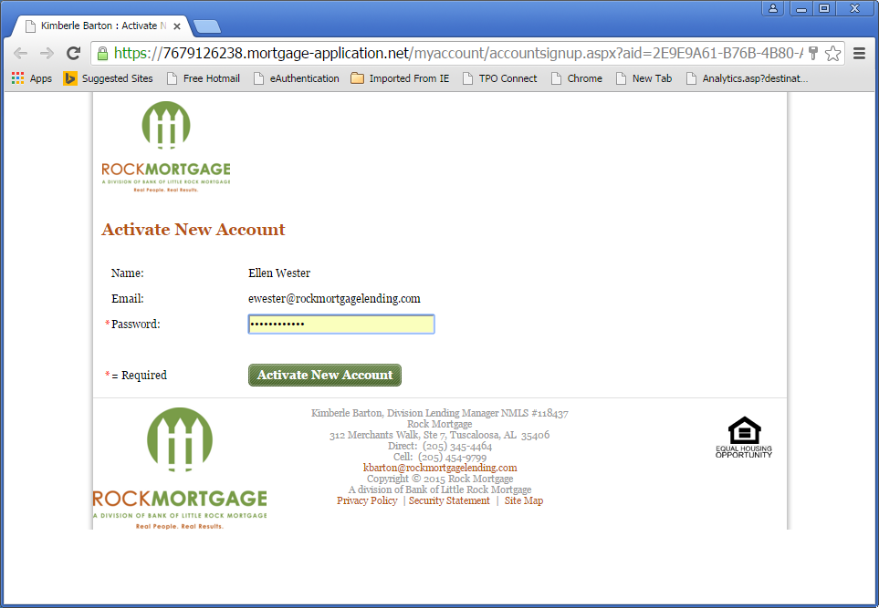

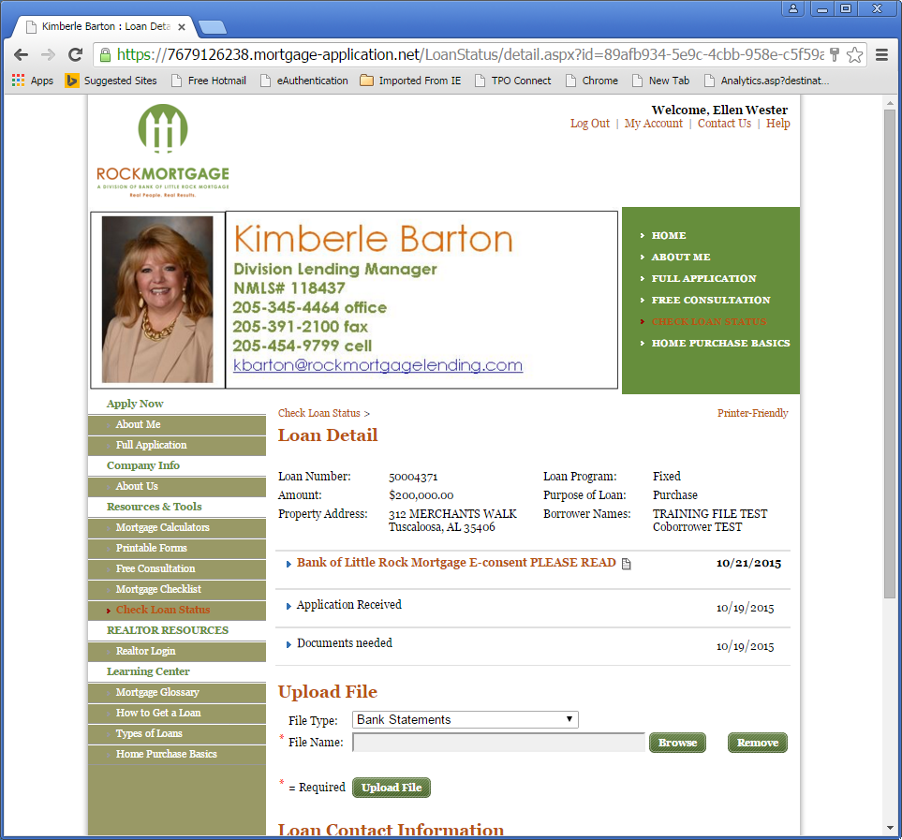
Once they login they will click on their loan file and open the dropdown for E-consent (below)
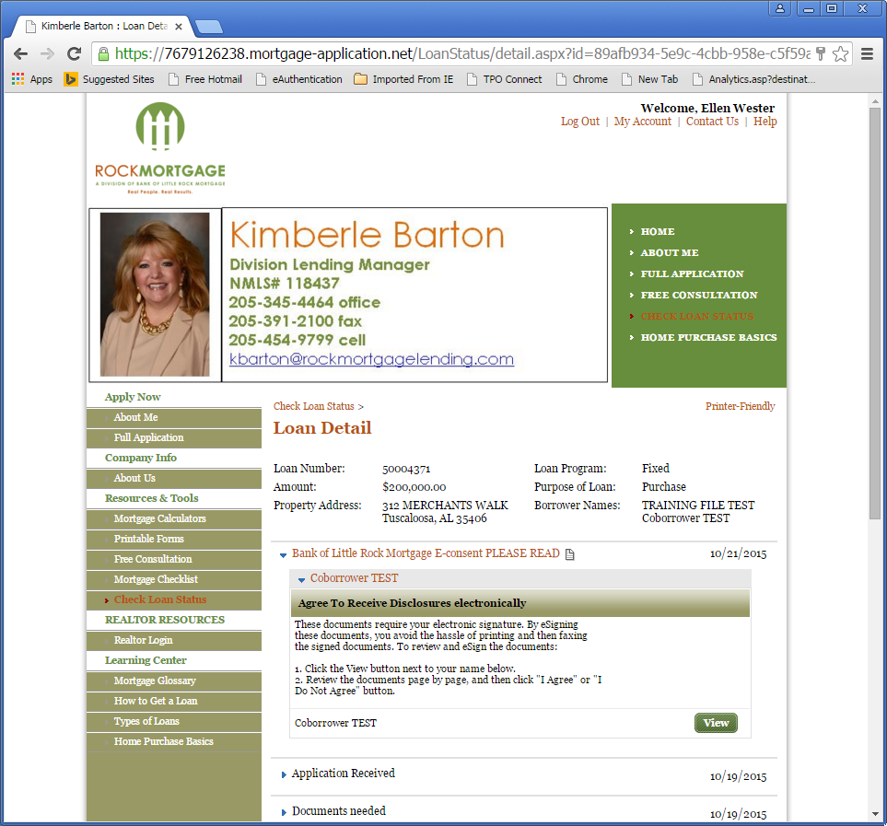

Click View
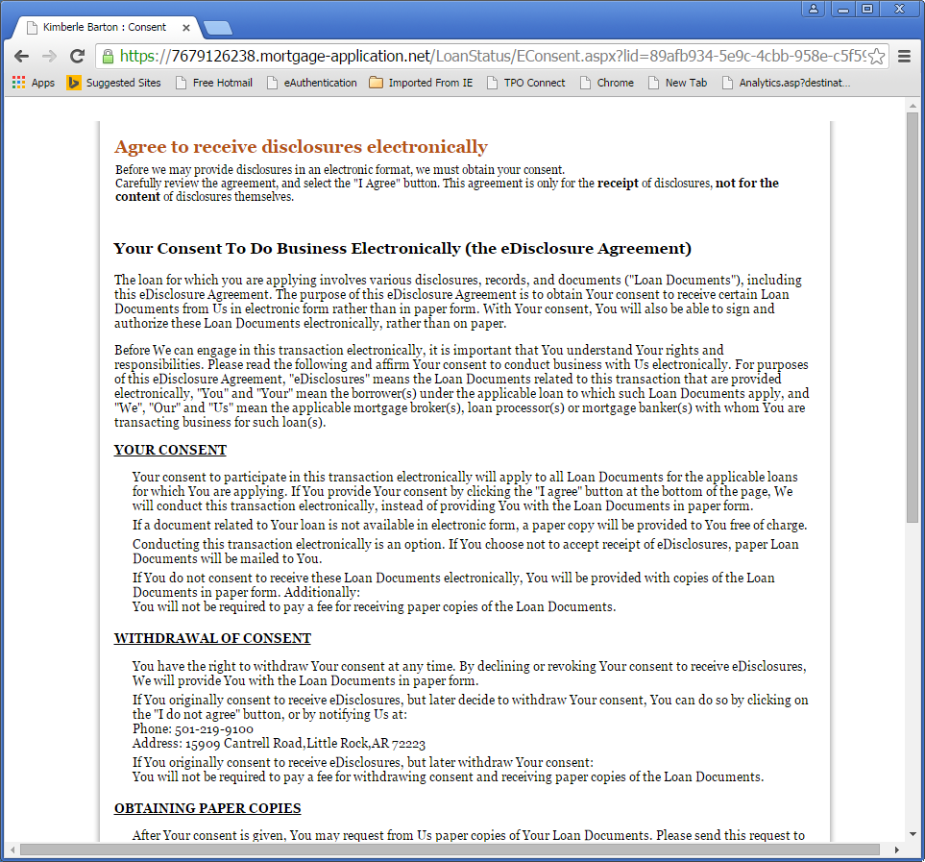
Scroll through and red the agreement.
Once read click “I Agree”
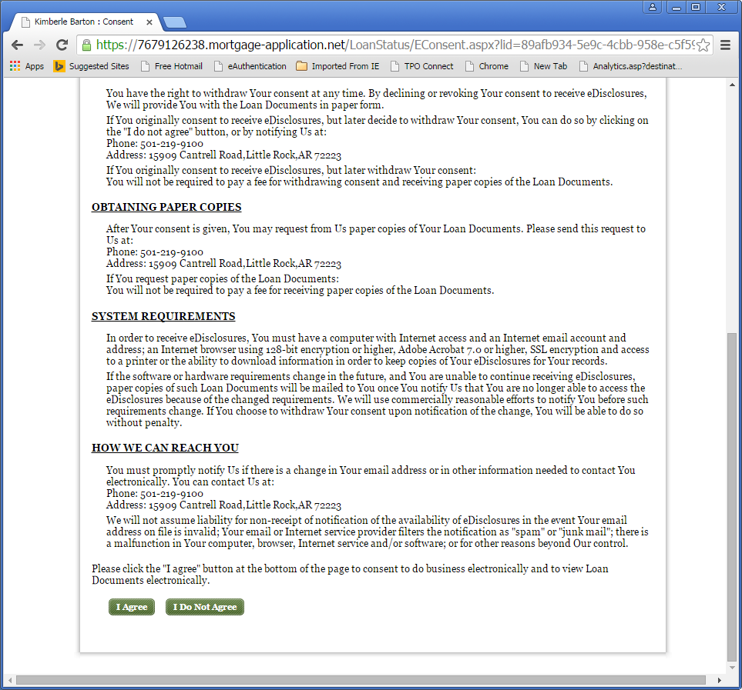
Once agreed your borrower will get below thank you and you will get an email confirmation.
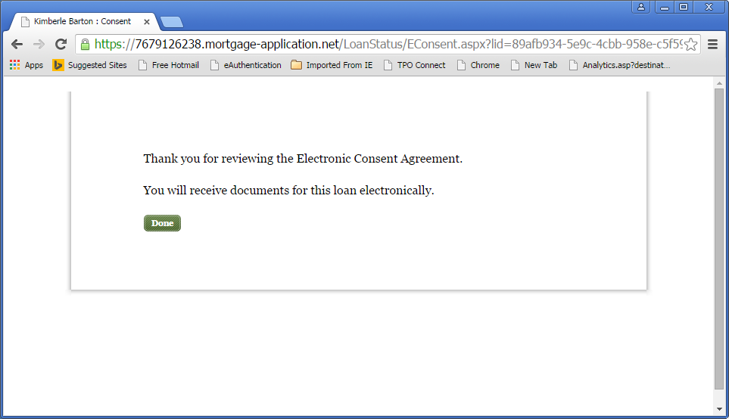
From: eFolder@elliemae.com [mailto:eFolder@elliemae.com]
Sent: Tuesday, September 29, 2015 2:22 PM
To: Ellen Wester
Subject: eConsent Accepted - ELLENTESTING TRIDTEST 50004125

Borrower/Co-Borrower: ELLENTESTING TRIDTEST
Property Address: 1500 Test Street, Tuscaloosa, AL, 35406
Consent Request Sent Date/Time: 9/29/2015 12:15 PM
Current Status: Accepted on 9/29/2015 12:22:00 PM
Dear Ellen Wester,
This email has been sent to notify you that ELLENTESTING TRIDTEST has received the consent request you sent on 9/29/2015 12:15 PM and has agreed to receive documents electronically for this loan.
Please retain this email as proof of ELLENTESTING TRIDTEST's consent to receive documents electronically for this loan. In the future, if ELLENTESTING TRIDTEST chooses to decline to receive documents online, you will be notified in a separate email. Please do not respond to this email. This mailbox is not monitored. If you have questions about this message, please contact your Encompass Systems Administrator.
Sincerely,
Encompass eFolder Team
Ellie Mae, Inc.

Once eConsent has been completed and credit pulled for a TBD file send the credit disclosures and add in the following disclosures that need “real” signatures for them to sign and return immediately: 4506, SSI forms and borrower’s authorization.
